Minerals are inorganic substances (elements) required in small amounts by the body.
They function in a number of processes including formation of bones and teeth, fluid balance, nerve conduction, muscle contraction, signaling, and catalysis.
Classification
- Essential elements: they are required for life maintenance and their deficiency or absence might cause malfunction or death.
- Non essential elements: do not play any positive role in biological systems.

Minerals are micronutrients required in mg or µg amounts.
- Those required by adults in the largest amounts (>100 mg/day) are referred to as the macrominerals.
- Minerals required in amounts between 1 and 100 mg/day are the microminerals (trace minerals). They include: copper (Cu), iron (Fe), manganese (Mn), and zinc (Zn).
- Ultratrace minerals are required in amounts <1 mg/day .
Mineral concentrations in the body are influenced by their rates of absorption and excretion.

Iron
The adult body typically contains 3–4 g of Fe.
Distribution:
Iron is present mainly in blood (75%), the rest is in the liver, bone marrow and muscle. Iron is present almost in all cells.
Iron is associated with 3 proteins
- Hemoproteins:
- Haemoglobin: oxygen transport protein
- Myoglobin: protein found mainly in muscle tissue where it serve as an intracellular storage site for oxygen.
- Cytochrome: electron transfer protein.

- Iron transporter proteins.
Transferrin: it binds tightly with 2 irons. It transport iron from GIT to bone marrow (ferritin).
- Iron storage proteins.
Ferritin: in liver, spleen and bone marrow.
Hemosiderin: in liver, spleen and bone marrow. It is less soluble than ferritin and iron is more slowly released.
Free ionic Fe is toxic because ????
Absorption, storage, and transport:
- Dietary Fe is available as Fe²⁺ in heme (animal sources) and Fe³⁺ in nonheme sources (plants). Heme iron is less abundant, but it is better absorbed. Meat, poultry, some shellfish, ready-to-eat cereals, lentils, and molasses are good dietary sources of Fe.
- About 5-10% of ingested Fe is absorbed. This amount, ~1−2 mg/day, is sufficient to replace Fe lost from the body primarily by the sloughing of cells.why??
- Intestinal uptake of heme is by a heme carrier protein. Within the enterocytes, heme oxygenase releases Fe²⁺ from heme. Nonheme Fe is taken up via the apical membrane protein divalent metal ion transporter-1 (DMT-1).
- Note: Vitamin C enhances absorption of nonheme Fe because it is the coenzyme for duodenal cytochrome b (Dcytb), a ferrireductase that reduces Fe³⁺ to Fe²⁺.
- Absorbed Fe²⁺ from heme and nonheme sources has two possible fates: It can be 1) oxidized to Fe³⁺ and stored by the intracellular protein ferritin (up to 4,500 Fe^{3+/}ferritin) or 2) transported out of the enterocyte by the basolateral membrane protein ferroportin, oxidized by the Cu-containing membrane protein hephaestin, and taken up by the plasma transport protein transferrin (2 Fe³⁺/transferrin). [Note: Cells other than enterocytes use the Cu containing plasma protein ceruloplasmin in place of hephaestin.]
- Ferroportin, the only known exporter of Fe from cells to the blood in humans, is regulated by the hepatic peptide hepcidin that induces internalization and lysosomal degradation of ferroportin. Therefore, hepcidin is the central molecule in Fe homeostasis. [Note: Transcription of hepcidin is suppressed when Fe is deficient.]

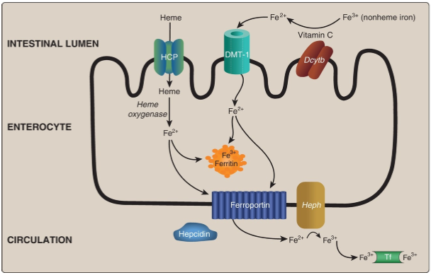
Factors affecting iron absorption:
- pH: acidic media facilitate iron absorption.
- Human need: children and pregnancy required and absorbed more iron than others.
- Antacid, tannin and polyphenol: they reduce iron absorption.
- Animal sources of iron is better absorbed than plant sources.
Recycling:
Macrophages phagocytose old and/or damaged red blood cells (RBC), freeing heme Fe that is sent out of the cells via ferroportin, oxidized by ceruloplasmin, and transported by transferrin. This recycled Fe meets ~90% of our daily need, which is predominantly for erythropoiesis.
Deficiency:
Fe deficiency can result in a microcytic, hypochromic anemia, as a result of decreased hemoglobin synthesis and, consequently, decreased RBC size.

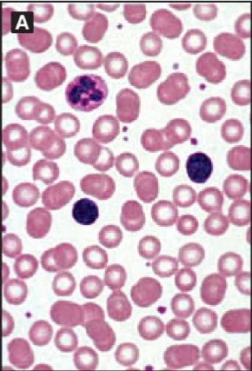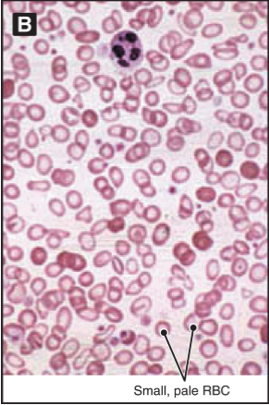
Treatment is the administration of Fe.
- Oral: iron salts should be given by mouth unless there are good reasons for using another route. Ferrous salts show only marginal differences between one another in efficiency of absorption of iron. Choice of preparation is thus usually decided by the incidence of side effects and cost.

- Ferrous sulfate (FeSO₄) tab (300 mg). It contains 60 mg ferrous iron. Dose: 2-3 times/ day.
- Ferrous fumarate tab (200 mg). It contains 65 mg ferrous iron. Dose: 2-3 times/ day.
- Ferrous gluconate tab (300 mg). It contains 35 mg ferrous iron. Dose: 2 tab 2-4 times/day.
- Iron III hydroxide polymaltose oral solution
- Iron III hydroxide polymaltose chewable tab
- Iron proteinsuccinylate oral solution

- Paranteral
- iron dextrans (Cosmofer®): may be given as IM, slow IV injection, or IV infusion.
- Iron sucrose (Venofer®): slow intravenous injection or IV infusion
- Iron sorbitol (jectofer ®): IM only.
- Iron III hydroxide polymaltose: IM

Toxicity (hemochromatosis):
Iron overload occurs when there are excess stores of iron in the body. Primary iron overload is often inherited (hereditary hemochromatosis). Secondary iron overload usually arises from causes such as transfusion, hemolysis, or excessive parenteral and/or dietary consumption of iron. This can damage parts of the body such as the liver, joints, pancreas and heart.
Treatment
- Phlebotomy
- Deferoxamine, a chelating agent that can remove iron from tissues and free iron from plasma

